THE PARTNER STUDY

AN INTERNATIONAL PROSPECTIVE OBSERVATIONAL STUDY
ON PEDIATRIC PATIENTS WITH VERY RARE TUMORS

An EXPeRT Study

Vers. 4.0 – May 2023

Abstracts

Paediatric Rare Tumours Network European Registry (PARTNER) is a project launched in 2018 and part of the European Reference Network for Paediatric Cancer (ERN PaedCan), supported by the EU, which approved the project in 2016.
PARTNER represents an important step in the development of EXPeRT activities devoted to children with VRTs and his main aim is to create a single European Registry that links the existing national registries dedicated to children and adolescents (0–18 years) with VRTs and to provide a registry for those countries not already having a registry for VRT in place.
The possibility to link the registry with a virtual consultation system and the elaboration of diagnostic/treatment recommendations will create a platform that can be easily accessed by EU Health care providers.
The increasing expertise in VRT based on the data collected in the European registry will increase the capacity to provide international consultation and define standard of treatment recommendations. This will ultimately result in improved patients care and reduce currently existing inequalities in cancer outcome across EU member states.

Principal Investigator | Gianni Bisogno
 | Department for Women and Children Health
 | Azienda Ospedale Università di Padova
Via Giustiniani, 3 - 35128 Padova – ITALY
gianni.bisogno@unipd.it

Coordinating Centre | Azienda Ospedale - Università di Padova  Via Giustiniani, 3 - 35128 Padova – ITALY
Trial Management Committee | EXPeRT Board members (see Appendix 1)

Participating countries and National Coordinators (please include your name and country)

(In some countries 2 national coordinators working in different institutions have bene identified)

Country | National Coordinator | Centre (please insert the correct name with the complete adress) | e-mail address | Notes
Austria | Ruth Ladenstein | St. Anna, Wien
Croatia | Jelena Roganovic | Clinical Hospital, Rijeka
France 1 | Yves Reguerre | Centre Hospitalier Universitaire, La Réunion
France 2 | Daniel Orbach | Institut Curie, Paris
Germany 1 | Ines Brecht | Eberhard Karls Universitaet, Tuebingen
Germany 2 | Dominik Schneider | Klinikum Dortmund
Greece | Apostolos Pourtsidis | Mitera Children's Hospital, Marousi Attica
Israel | Tal Ben-Ami | Kaplan Medical Center Rehovot Israel
Italy 1 | Gianni Bisogno | Azienda Ospedale-Università di Padova  vai gistiniani, 3 - 3120 padova
Italy 2 | Andrea Ferrari | Istituto Nazionale Tumori
Lithuania | Jelena Rascon | University Children’s Hospital  Vilnius
Macedonia | Kata Martinova | University Children's Hospital, Skopje
Poland | Ewa Bien | Gdanski Uniwesytet Medyczny, Gdansk
Portugal | Nuno Jorge dos Reis Farinha | São João, Porto
Rumania 1 | Monica Désirée Dragomir | Institute of Oncology "Prof. Dr. Al. Trestioreanu, Bucharest
Rumania 2 | Rodica Cosnarovici | Oncology Institute "Prof.Dr.Ion Chiricuta", Cluj-Napoca
Serbia | Dragana Janic | Institute for Oncology and Radiology of Serbia, Belgrade
Slovakia | Alexandra Kolenova | National Institute of Children’s Disease, Bratislava
Slovenia | Maja Cesen Mazic | University Children’s Hospital Ljubljana, Ljubljana
Spain | Ricardo López Almaraz | Oncología-Hematología pediátrica - Hospital Universitario Cruces, Barakaldo-Bizkaia (Bilbao)
Sweden | Gustaf Osterlundh | The Queen Silvia Children's Hospital University of Gothenburg

1.1 BACKGROUND AND RATIONALE

Malignant tumors are rare in children, with an annual incidence rate of 12,7 new cases per 100.000 children per year in Europe (ref). They are constituted by a broad spectrum of histologies with various clinical and biological characteristics. Leukemia and brain tumors are the most frequent diagnosis, followed by less common entities (Figure 1).
The impossibility of performing meaningful studies on the small number of patients treated in each pediatric oncology center has fostered links and collaboration, initially on a national level and subsequently to a more international dimension. National and international networks have been founded, and international cooperative studies have been initiated. The results of this increasing collaboration are evident in the progressive improvement of the survival and cure rates obtained in almost all pediatric tumors (1).

Figure 1 – Incidence of cancer in children aged 0-14 years (2006-2008 United Kingdom)
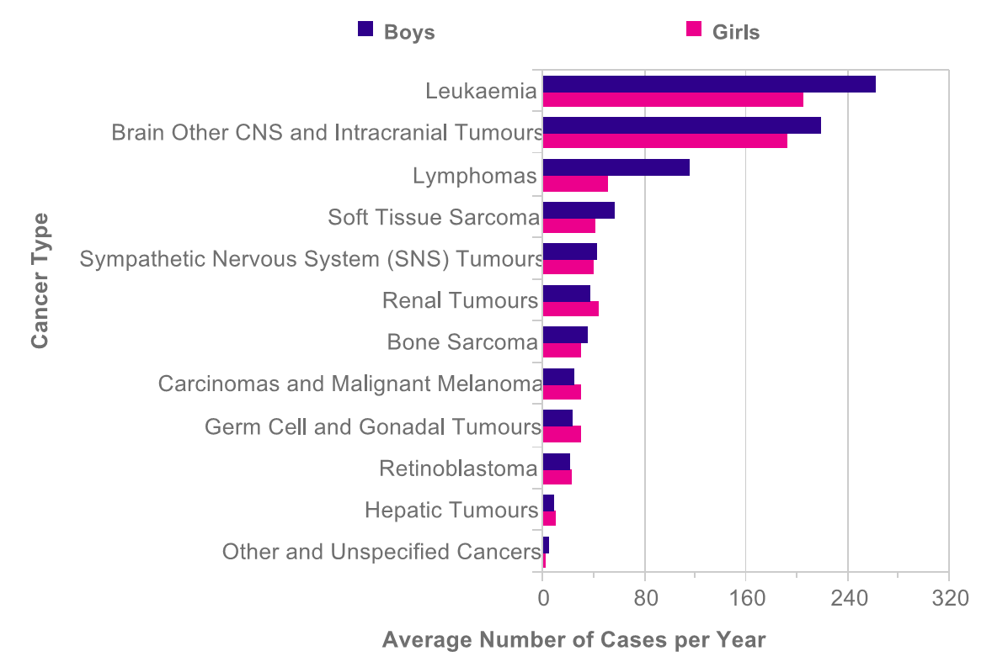
From: http://www.cancerresearchuk.org/health-professional/cancer-statistics/childrens-cancers

A small but significant group of children with extremely rare tumors only partially benefit from this effort. Very rare tumors (VRT) in children and adolescents form a heterogeneous group of cancers rarely observed in clinical practice, even in large pediatric oncology centers.
The international definition adopted in Europe for VRT includes any solid malignancies characterized by an annual incidence of < 2/millions of children (2).
This extremely low incidence often has limited research and the collection of significant clinical and laboratory data. Consequently, it is complicated to produce evidence-based treatment guidelines, and physicians are forced to treat children with VRT on an individual basis.
VRT show variable epidemiological patterns, may arise at virtually all anatomic sites with variable histology, and may be associated with an underlying genetic predisposition. Some VRT characteristically occur at the pediatric age, such as pleuropulmonary blastoma or pancreatoblastoma. Other tumors more commonly develop during adulthood or may even be frequent in adult patients (i.e., colon cancer or malignant melanoma), but only rarely develop in children and adolescents. There is growing evidence that at least some of them are biologically and clinically distinct from their adult counterparts. Lastly , a substantial group of “borderline” tumors with uncertain clinical behavior and no standard treatments are also included in the group of VRT.
However, the aetiology, biology and clinical course of some adult-type tumors seem to be different when they occur in children [2,3]. In spite of this, due to lack of evidence, diagnostic and treatment strategies for children affected by adult-type VRT are, in the majority of cases, adopted from those applied to adults, leading to either a worse prognosis or overtreatment in many cases [2].
In adults, most malignancies occur as a result of the accumulation of genetic somatic alterations following long-term exposure to carcinogens or spontaneously. In contrast, due to the short life-span cancer may not result from the same causative factors in children [4].
In addition, several studies have underlined how cancer biology may change according to age, highlighting differences in genomic, transcriptomic, epigenetic, and immunological landscape, as well as in tumor histology and subtype distribution [5-9]. However, these reports mainly focus on adult oncology and generally do not include children and adolescents with cancer.
The most intriguing hypothesis, which in part includes the previous ones, defines most pediatric cancers as a developmental disease, which occurs after a clonal genetic driver event. This may cause a maturation block, in specific cell lineages during defined developmental windows. In contrast, adult-type cancer is a result of an accumulation of mutations due to aging, cell division, and exposure to external mutagenic factors [15]. This theory may better explain the tight relationship of some pediatric tumors to developmental stages (i.e. neuroblastoma, acute lymphoblastic leukemia and a subgroup of adrenocortical tumors), their overlap with embryonal tissue (i.e. hepatoblastoma, Wilms tumor), and their spontaneous or chemo-induced differentiation (i.e. infant neuroblastoma and rhabdomyosarcoma respectively). Pediatric tumors generally show a lower burden of genetic aberrations and very limited immune cell infiltration and are therefore immunologically “cold” tumors [16].
Table I reports various tumors included by this definition, with emphasis that this list needs to be updated regularly. New entities are continuously identified thanks to the new pathologic or biological tools. It has been calculated that cumulatively they represent up to 11% of all cancers in patients aged 0-14 years (2,3).

Table I – Main Vary Rare Tumors in pediatric age

- Adrenocortical tumors
- Appendiceal Neuroendocrine Tumors
- Esthesio-Neuroblastoma
- Extra-appendicular Neuroendocrine Tumors
- Gastrointestinal Stromal Tumors (GIST)
- Gonadal non-germ cell tumors
- Melanoma and Melanocytic tumors of uncertain malignant potential (MELTUMP)
- Mesothelioma
- Nasopharyngeal carcinoma
- NUT Carcinoma
- Pancreatic tumors
- Pheochromocytoma and Paraganglioma
- Pleuropulmonary Blastoma (PPB)
- Salivary Gland Tumors
- Thymic tumors
- Thyroid carcinoma
- Other VRT

After the year 2000, national groups that specifically focus on VRT in childhood were founded [1,2]. These initiatives have increased the awareness of the problem of VRT in children and adolescents. Ultimately, in June 2008 they led to the formation of a new cooperative group denominated EXPeRT – European Cooperative Study Group for Paediatric Rare Tumors (4,5).
This group has worked efficiently to establish collaborations among five European countries and to create systematic joint retrospective analyses of various VRT. Due to the success of this initiative and the unresponded needs of children with VRT in the following years, the number of countries where a research group dedicated to VRT has been established increased.

1.2 NATIONAL COOPERATIVE GROUPS DEDICATED TO VRT
A survey performed in 2015 as part of the EXPO-r-Net project revealed that VRT cooperative groups existed in Italy, Germany/Austria, Poland, France, Spain, and The Netherlands. A tumor registry including VRT is active in the UK/Ireland and Hungary (5).
Thus, structured activities dedicated to children with VRT exist in only 30% of European countries which translates into “coverage” of approximately 60% of the European population.

1.2.1 The TREP project
The first registry specifically dedicated to childhood VRT started in Italy in 2000 with the launch of the TREP project under the auspices of AIEOP (Associazione Italiana di Ematologia e Oncologia Pediatrica) (1). This project established a network of pediatric oncology and pediatric surgery centers cooperating with experts on adult cancer, developed diagnostic and therapeutic guidelines, registered patients centrally, collected tumor samples, and promoted biological studies. The TREP project also provided an advisory service to the Italian pediatric oncology centers part of the network. The data collected over the years have been the object of various studies published and the writing of national recommendations for diagnosis and treatment of VRT (1).

1.2.2 Polish Rare Paediatric Tumour Study Group (PPRSTG)
The Polish Rare Paediatric Tumour Study Group (PPRSTG) was launched in 2002 as a working group within the Polish Pediatric Solid Tumors Study Group, under auspices of the Polish Society of Pediatric Oncology and Hematology (PTOHD). However, some types of VRT, such as thyroid cancer, hepatocarcinoma, and rare mesenchymal tumors (CWS/SoTiSar) have been previously registered in prospective studies and/or registries. The PPRSTG started its activities with several national retrospective analys, followed by the development of an active advisory consultation service for oncologists. The prospective collection of new patients with VRT was planned, however, due to organizational and technical obstacles, the data was collected via paper forms and then was transferred to an excel database. Data have been collected in a paper-forms transferred to the rather. The treatment recommendations for particular types of VRT were continuously reevaluated, improved and shared within all pediatric oncology and surgery centers of the PTOHD. The results of these activities have been reported in several articles and congress abstracts (ref).

1.2.3 German Rare Tumour Working Group “Seltene Tumoren in der Pädiatrie” (STEP)
In 2006, the German Rare Tumour Working Group “Seltene Tumoren in der Pädiatrie” (STEP) was founded as a working group of the German Society of Paediatric Oncology and Hematology (GPOH). In Germany, some specific rare tumor entities such as rare gonadal (MAKEI) and endocrine (MET) cancers, rare mesenchymal tumors (CWS/SoTiSar) and nasopharyngeal tumors (NPC) have been registered in prospective studies and registries for many years, respectively. For other VRTs, STEP was founded in 2006 and became an official registry of the GPOH in 2012. Since then, a registration rate of up to 100 patients per year from cooperating pediatric oncology centers in Germany, Austria, and Switzerland has been achieved. STEP scientific activities have been translated into a series of publications. A consultation and reference center for rare pediatric tumors is coordinated by STEP, and information is provided to physicians and parents through the internet platform www.kinderkrebsinfo.de. (6)

1.2.4 French Rare Tumor Group, “FRACTURE.”
The French Rare Tumor Group, named “FRACTURE” (Groupe FRAnCais des TUmeurs Rares de l’Enfant), was founded in 2007 on behalf of the French Oncological Pediatric Society (SFCE) and in association with the French national cancer registry. The goals of FRACTURE explicitly included the registration not only for all malignant VRTs but also for intermediate malignant and benign tumors, which may lead to difficult therapeutic discussions, including chemotherapy or radiotherapy. For this purpose, a new database for prospective registry of clinical, therapeutic , and follow up data was set up. Moreover, interdisciplinary collaboration was supported, and therapeutic recommendations were developed and distributed through SFCE website for society members. (7).
In France, the very Rare Tumor Committee (FRACTURE) of the Société Française de lutte contre les Cancers et les leucémies de l’Enfant et de l’adolescent (French Society of Pediatric Oncology - SFCE) was founded in 2007 with several objectives. Its main aim was to record as many childhood and adolescent cases of VRTs as possible on a national scale, using the FRACTURE database, a national collection database open since 2012. The purpose of the database was to facilitate analysis of these rare diseases, mainly in order to develop harmonized dedicated guidelines for diagnosis, treatment and follow-up. All French pediatric centers can register patients in the database. Entities with another SFCE Committee like malignant germ cells tumors or liver tumors are not registered in the FRACTURE database to avoid double registration. Periodic national meetings on very rare tumors are organized each year (one or 2 per year) to work on a specific entity and to share database results on this specific topic. National retrospective studies have already been published with information from the database (ref).

1.2.5 Further VRT National registry sources
Even if a registry dedicated to collecting data on children with VRT does not exist in other European countries, general data can be retrieved from hospital-based national registries.
Examples are the National Registry of Childhood Tumours (NRCT) in the United Kingdom and the RETI (Registro Espagnol Tumores Infantiles) in Spain.

1.2.6 EXPeRT – European Cooperative Study Group for Paediatric Rare Tumours
It has soon become evident to all national groups that international collaboration is essential to substantially promote the issue of VRT and significantly accelerate scientific progress. Thus, EXPeRT was founded in June 2008 by the national VRT groups of France, Germany/Austria, Italy, Poland, and the United Kingdom (4).
As an initial activity EXPeRT decided to join data collected by each national group on specific VRT and perform retrospective analyses. Results of this collaboration have been published and prove the strong collaboration among the groups and the capability of working together.
However, data were collected retrospectively, and no joint registry was established due to the lack of funding for such an ambitious endeavor.

1.3 EUROPEAN PROJECTS

A significant step was achieved in 2004 when the established activity of EXPeRT started to be supported by the European Community through two subsequent projects.

The ExPO-r-Net Project
The European Expert Paediatric Oncology Reference Network for Diagnostics and Treatment (ExPO-r-Net) project (2014–2017) was funded by the EU (in the framework of its Health Programme 2008–2013) and developed under an EU directive focusing on patients’ rights and health care across the EU. ExPOr-Net created a model that was subsequently developed into the European Reference Network on Paediatric Cancer (ERN PaedCan). One of the objectives of ExPO-r-Net was to link existing hubs to coordinate the treatment and management of childhood cancers. The involvement of EXPeRT, therefore, provided the basis for establishing a pilot reference subnetwork of centers dedicated to children and adolescents with VRT as part of the ERN PaedCan (figure 2)
As part of this project, an international advisory desk with a virtual consultation system has been established to provide expert advice on complex cases (8). The preparation of diagnosis and treatment guidelines for the first group of VRT has also been initiated.
In ExPO-r- Net, the necessity to establish a structure dedicated to data collection on children with VRT on an EU basis was underlined.

Figure 2 – European subnetwork for children and adolescents with very rare tumors.

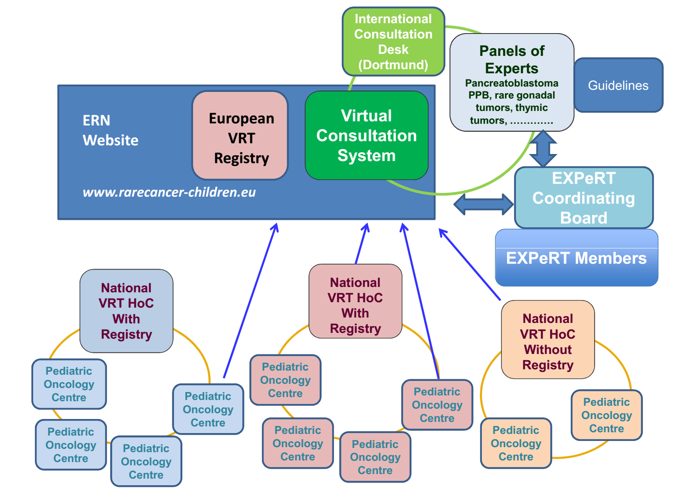

EU Joint Action for Rare Cancers (JARC) project

Thanks to the participation in this project, the EXPeRT group strengthens the cooperation between pediatric and adult oncology. This project allows to establish a list of rare tumors and confirm the definition (< 2/million children/year) initially adopted by the national groups. (9)

The PARTNER Project
This project was denominated Paediatric Rare Tumours Network European Registry (PARTNER) and was open in 2018.
The project's general objective was to create a European Registry dedicated to linking existing national registries and providing a registry for those countries not already having a registry for VRT. The European Registry is considered an essential part of the activity of the VRT subnetwork part of the ERN PaedCan. The possibility of linking the registry with a virtual consultation system and elaborating diagnostic/treatment recommendations can create a platform that EU collected may increase the capacity to provide international consultation and define the standard of treatment recommendations. The ultimately expected results are improving patient care and reducing currently existing inequalities in cancer outcomes across EU member states.
Given the differences between health systems and the inequalities between the EU Member States in terms of the management of children with VRT, PARTNER has always strived to involve so-called low health expenditure average rate (LHEAR) Member States in the process of registry construction and the development of clinical practice guidelines. Consequently, the project had a comprehensive geographic coverage. Five countries (Italy, Germany, France, Poland, and Austria) have been involved as associate partners, and another 23 countries participated as collaborating partners, including 11 centers from LHEAR countries, two non-EU countries, and one parent organization (9)

THE PARTNER STUDY
This study derives from previous projects and aims to use the EXPERT network and the infrastructure established by the partner project to collect data on patients with VRT in European countries.

Design of the study
This is an observational and prospective multicenter international study.

Primary aims:
The primary purposes of the study are

- to evaluate the epidemiology and survival of children and adolescents (0-18 years) affected by VRT diagnosed and treated in the participating countries in relation to the various clinical, biological, histological, biochemical and molecular genetic risk factors and the treatments received. In particular we will correlate:
- the characteristics of the patient and his therapeutic diagnostic history (e.g. age, sex, the presence of predisposing syndromes, geographical area of origin, time to reach the diagnosis, ...) with the treatment, the risk of recurrence and survival
- the clinical characteristics of the tumor (e.g. size, site, extension) with the treatment, the risk of recurrence and survival
- the radiological characteristics of the tumor with treatment, the risk of recurrence and survival
- the biological characteristics of the tumor with the treatment, the risk of recurrence and survival

2) to analyze how they are treated in the different European countries and evaluate if the international recommendations for diagnosis and treatment have been adopted.
In addition
- the characteristics of the treatment given will be correlated with the risk of recurrence and survival
- the development of late side effects or second tumors will be correlated with possible predisposing genetic alterations and the type of treatment

Note: This is not a therapeutic trial, as there are no drugs or specific treatments to be evaluated.

Inclusion criteria
- All children and adolescents (age 0-18 years) with a primary or relapsed VRT (see the list of tumors - appendix 2) diagnosed in a participating country/center are eligible for inclusion in the study
- All registered and participating countries must enroll all their patients with VRT in this study if the patient, parent, or legal representative gives informed consent.

Exclusion criteria
The only exclusion criteria is missing informed consent. Patients who do not give or whose parents or guardians who do not consent to inclusion in the study cannot be registered. Each country will provide consent forms in their language according to local regulations rules.

Duration of the study and time of enrollment
Due to the low number of patients diagnosed in each VRT category it is necessary a long time to enroll a significant number of patients.
Therefore the study will enroll patients until 31/12/2033.

GENERAL TREATMENT GUIDELINES
This is an observational study and not a treatment study. There are no questions about treatment. In this sense, this study is not falling under the Clinical Trial Directive 2001

We recommend following international or national recommendations for diagnosis and treatment of patients with VRTs.
In case recommendations do not exist, it is possible to ask for advice through the virtual consultation system (see appendix 3) that can be accessed through the EXPeRT website: https://www.raretumors-children.eu

Table 2 shows the list of the tumors for whom the EXpERT group has published international recommendations as part of the PARTNER project. EXPeRT will periodically update these recommendations. More recommendations for additional tumors are expected to be published in the next years.

Table 2. List of EXPeRT recommendations

VRTs | Reference | Comments
Sex Cord stromal tumors | Schneider DT et al. Pediatr Blood Cancer. 2021 Jun;68 Suppl 4:e29017. doi: 10.1002/pbc.29017. Epub 2021 Mar 24. PMID: 33760357.
Pleuropulmonary blastoma | Bisogno G et al. Pediatr Blood Cancer. 2021 Jun;68 Suppl 4(Suppl 4):e29045. doi: 10.1002/pbc.29045. Epub 2021 Apr 7. PMID: 33826235.
Nasopharyngeal carcinoma | Ben-Ami T et al. Pediatr Blood Cancer. 2021 Jun;68 Suppl 4:e29018. doi: 10.1002/pbc.29018. Epub 2021 Apr 12. PMID: 33844410.
Thymoma and thymic carcinoma | Stachowicz-Stencel T et al. Pediatr Blood Cancer. 2021 Jun;68 Suppl 4:e29042. doi: 10.1002/pbc.29042. Epub 2021 Apr 21. PMID: 33881200.
Pancreatoblastoma | Bien E et al. Pediatr Blood Cancer. 2021 Jun;68 Suppl 4:e29112. doi: 10.1002/pbc.29112. PMID: 34174157
Cutaneous melanoma | Ferrari A et al. Pediatr Blood Cancer. 2021 Jun;68 Suppl 4:e28992. doi: 10.1002/pbc.28992. PMID: 34174159
Salivary gland carcinoma | Surun A et al. Pediatr Blood Cancer. 2021 Jun;68 Suppl 4:e29058. doi: 10.1002/pbc.29058. PMID: 34174160.
Adrenocortical tumors | Virgone C et al. Pediatr Blood Cancer. 2021 Jun;68 Suppl 4:e29025. doi: 10.1002/pbc.29025. PMID: 34174161.
NUT Carcinoma | Lemelle L et al. J Pediatr Hematol Oncol. 2023 May 1;45(4):165-173. doi: 10.1097/MPH.0000000000002568. Epub 2022 Oct 10. PMID: 36219702.

Standard Clinical Practice Protocols prepared by the Expert group may also be found in the SIOP Europe website https://siope.eu/ESCP/members

We will inform the study participating centers if recommendations will be updated or new recommendations will be prepared.

IT INFRASTRUCTURE AND DATA MANAGEMENT
For this study, an IT infrastructure has been established during the PARTNER project that allows joining heterogeneous data from different centers and national registries in a secure way, respecting GCP regulations for trials, including data protection and privacy.
Data River has been chosen as the leading eCRF system. This system provides tools for patient registration, data collection, querying, and (remote) monitoring. In addition, Electronic Case Record Forms (eCRFs) have been developed to collect baseline characteristics, pathology treatment details, and outcome measures.

The data management will change according to the organization of the participating countries.
Countries where a national registry is in place (Italy, Germany, France) will collect the data on a national level, and the data requested by this study will be transferred from the national database to PARTNER infrastructure approximately every six months. Each patient will be pseudoanonimyzed at a national level. No information that can identify patients will be transferred to the PARTNER database. Specific consent for data transfer will be proposed to parents/patients/legal guardians. Pseudo- anonymisation will be necessary to allow regular up date of the population studied.

Countries, where a national database is not in place, will directly include patients’ data in the PARTNER database. After parents/patient/legal guardian consent, the new patient will be enrolled in the study and will be identified anonymously at a national level with a unique identification code. Only the attending physician and authorized persons can link this identification code to the patient's name. No information that can identify patients will be transferred to the PARTNER database.

The general study management will be under the Clinical Trials Office of the Department of Women’ s and Children’s Health of Padua. Reports on the recruitment status and quality of the study, data on long-term survival, and incidence of secondary malignancies will be periodically drawn up.
The EXPeRT Board members will have the supervision of analysis and results.

Statistical analysis
Statistical analyzes will be carried out under the supervision of the study coordinators, and they may vary over time depending on the specific objectives that will be outlined. Routine analyses include the number of new diagnosis cases per year associated clinical and biological factors, treatment effects, survival rates as well as incidence of relapses and second tumors.

Sample size:
About 200 new cases per year are expected to be enrolled.

ETHICAL AND REGULATORY ASPECTS
Each national coordinator will be in charge of obtaining the necessary authorizations and Ethical approval according to the European and national rules.

FINAL REPORT OF THE RESULTS OF THE STUDY
Reports will be periodically prepared to report on the status of recruitment and quality data, event onset and survival estimates. These data will constitute material for publication in national and international scientific journals.

APPENDIX

Appendix 1- List of EXpERT Board members

Appendix 2- List of Very Rare Tumours (VRT) collected into the PARTNER Platform.

Appendix 3 – The Virtual Consultation System

Apendix 4 - Molecular alterations in Very Rare tumors

Information sheets

Consent form

REFERENCES
- Ferrari A, Bisogno G, De Salvo GL, Indolfi P, Perilongo G, Cecchetto G; Italian Study on Rare Tumours in Paediatric Age (TREP); Associazione Italiana Ematologia Oncologia Pediatrica (AIEOP). The challenge of very rare tumours in childhood: the Italian TREP project. Eur J Cancer. 2007 Mar;43(4):654-9. doi: 10.1016/j.ejca.2006.08.028. Epub 2006 Oct 16. PMID: 17049226.

- Ferrari A, Brecht IB, Gatta G, et al. Defining and listing very rare cancers of paediatric age: consensus of the Joint Action on Rare Cancers in cooperation with the European Cooperative Study Group for Pediatric Rare Tumors. Eur J Cancer. 2019;110:120-126

- G. Bisogno, S. Sorbara, D.T. Schneider, A. Ferrari, G. Petrarulo, D. Orbach, I. Reguerre, I. Brecht, J. Godzinski, E. Bien, T. Stachowicz-Stencel, G. Cecchetto, R. Ladenstein. European survey on the existence and activity of cooperative groups dedicated to children and adolescents with very rare tumors. An ExPO-r-Net/EXPeRT initiative.

- Bisogno G, Ferrari A, Bien E, Brecht IB, Brennan B, Cecchetto G, Godzinski J, Orbach D, Reguerre Y, Stachowicz-Stencel T, Schneider DT . Rare cancers in children . The EXPeRT Initiative: a report from the European Cooperative Study Group on Pediatric Rare. Tumors. Klin Padiatr. 2012 Oct;224(6):41

- Ferrari A, Schneider DT, Bisogno G, Reguerre Y, Godzinski J, Bien E, Stachowicz-Stencel T, Cecchetto G, Brennan B, Roganovic J, Ben-Ami T, Virgone C, Farinha NR, Mancini S, Orbach D, Brecht IB. Facing the challenges of very rare tumors of pediatric age: The European Cooperative Study Group for Pediatric Rare Tumors (EXPeRT) background, goals, and achievements. Pediatr Blood Cancer. 2021 Jun;68 Suppl 4:e28993. doi: 10.1002/pbc.28993. PMID: 34174158.

- Brecht IB, Bremensdorfer C, Schneider DT, Frühwald MC, Offenmüller S, Mertens R, Vorwerk P, Koscielniak E, Bielack SS, Benesch M, Hero B, Graf N, von Schweinitz D, Kaatsch P. Rare malignant pediatric tumors registered in the German Childhood Cancer Registry 2001-2010. Pediatr Blood Cancer. 2014 Jul;61(7):1202-9. doi: 10.1002/pbc.24997. Epub 2014 Feb 28. PMID: 24585499.

- Mallebranche C, Reguerre Y, Fresneau B, Andre N, Berger C, Briandet C, Castex MP, Defachelles AS, Faure-Conter C, Lejeune J, Klein S, Leverger G, Marie-Cardine A, Oudot C, Freycon C, Proust S, Roumy M, Thebaud E, Verite C, Lacour B, Orbach D. The French FRACTURE database: A way to improve knowledge on management of children with very rare tumors. Pediatr Blood Cancer. 2022 Dec;69(12):e30003. doi: 10.1002/pbc.30003. Epub 2022 Sep 25. PMID: 36156381.

- D.T. Schneider, A. Ferrari, E. Bien, I.B. Brecht, B. Brennan, G. Cecchetto, J. Godzinski, F. Hippert T. Stachowicz-Stencel, D. Orbach, Y. Reguerre, R. Ladenstein, G. Bisogno. Steps towards an European Virtual Tumor Board for Very Rare Tumors. Interim Report from the European Cooperative Study Group on Pediatric Rare Tumors (EXPeRT) and the ExPO-r-NeT project.. Ped Blood cancerconcer 2015 62,S358.
- Orbach D, Ferrari A, Schneider DT, Reguerre Y, Godzinski J, Bien E, Stachowicz-Stencel T, Surun A, Almaraz RL, Dragomir M, Jani D, Ami TB, Roganovic J, Brecht IB, Ladenstein R, Bisogno G. The European Paediatric Rare Tumours Network - European Registry (PARTNER) project for very rare tumors in children. Pediatr Blood Cancer. 2021 Jun;68 Suppl 4:e29072. doi: 10.1002/pbc.29072. Epub 2021 Apr 29. PMID: 33913610.

More:
- Stiller CA, Marcos-Gragera R, Ardanaz E, Pannelli F, Almar Marqués E, Cañada Martinez A, Steliarova-Foucher E. Geographical patterns of childhood cancer incidence in Europe, 1988-1997. Report from the Automated Childhood Cancer. Information System project. Eur J Cancer. 2006 Sep;42(13):1952-60.

- Ebner H, Hayn D, Falgenhauer M, Nitzlnader M, Schleiermacher G, Haupt R, Erminio G, Defferrari R, Mazzocco K, Kohler J, Tonini GP, Ladenstein R, Schreier G. Piloting the European Patient Identity Management (EUPID) Concept to Facilitate Secondary Use of Neuroblastoma Data from Clinical Trials and Biobanking. Presented at the eHealth2016 - Health Informatics meets eHealth - Vienna, 2016. Stud Health Technol Inform. 2016;223:31-8.

- Hayn D, Falgenhauer M, Kropf M, Nitzlnader M, Welte S, Ebner H, Ladenstein R, Schleiermacher G, Hero B, Schreier G. IT Infrastructure for Merging Data from Different Clinical Trials and Across Independent Research Networks. Presented at the Medical Informatics Europe (MIE) - Munich, 2016. Stud Health Technol Inform. 2016;228:287-91.

Appendix 2 - List of EXPeRT Board members

Appendix 2- List of Very Rare Tumours (VRT) collected into the PARTNER Platform.

- Adrenocortical tumors
- Appendiceal Neuroendocrine Tumors
- Esthesio-Neuroblastoma
- Extra-appendicular Neuroendocrine Tumors
- Gastrointestinal Stromal Tumors – GIST
- Gonadal non-germ cell tumors
- Melanoma and MELTUMP [Melanocytic Tumors of Uncertain Malignant Potential]
- Mesothelioma
- Nasopharyngeal carcinoma
- NUT Carcinoma
- Pancreatic tumors
- Pheochromocytoma and Paraganglioma
- Pleuropulmonary Blastoma
- Salivary Gland Tumors
- Thymic tumors
- Thyroid carcinoma
- Carcinomas of appendix
- Carcinomas of bladder
- Carcinomas of breast
- Carcinomas of cervix uteri
- Carcinomas of colon and rectum
- Carcinomas of lung
- Carcinomas of other specified or unspecified sites
- Chondrosarcomas
- Chordomas
- Medulloepithelioma
- Neuroepithelioma
- Rare bone tumors
- Skin carcinomas
- Vascular tumors

Appendix 3 VIRTUAL CONSULTATION SYSTEM and multidisciplinary Virtual Tumor Board.
website access: https://www.raretumors-children.eu/for-professionals/

The virtual consulation system allow to discuss difficult cases in a multidisciplinary Virtual Tumor Board (VTB).
VTB can provide medical advice, allowing the patient to receive appropriate treatment in the local Centre, but can also facilitate direct communication with Centres with adequate expertise throughout Europe, if a particular treatment is needed.

The VTB can be contacted by physicians for requests regarding verification of diagnosis and optimal treatment. To ensure high quality of consultation, a set of data (i.e. clinical summary, pathology and radiology reports, etc.) is required along with the patient’s/family’s consent for consultation.

Only the patient’ responsible clinician or VRT national coordinator will be allowed to use the VTB system. The physician will go through an identification procedure.

Parents, patients or other, not professionals are not allowed to ask for advice and will be invited to submit their requests, however, through the responsible physician. This restriction is required in order to assure reliable source data and meaningful consultations processes.

Request concerning more frequent tumours will not be considered, as well as the general request for information or help.

Material has to be submitted, exclusively in English.

The request of advice to the VRT board must be sent after written informed consent has been obtained from the patient, parent or legal guardian. The request of consent is left to the treating physician in agreement with the local rule. The treating physician will confirm in the consultation form that the patient/legal tutor has been
informed about the advice request and have agreed on the procedure including the possibility for the Advisory Desk to store data, ask further data including follow up information and use data for future consultation and analysis.

In case of a problem in accessing the VCS you can contact the central Advisory Desk in Dortmund
Tel: +49-231-953 21680 Email: expert-advice@klinikumdo.de

The virtual consultation system is a deliverable of the ExPO-r-Net project that has been funded by The European Union in the framework of the Health Programme (2008-2013), grant 201312 07

